Tasks with Long Sequences

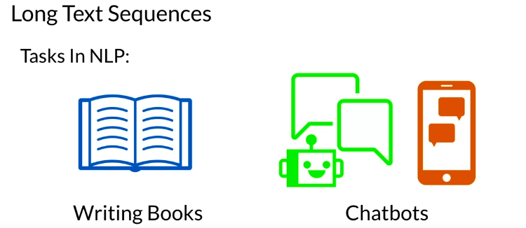

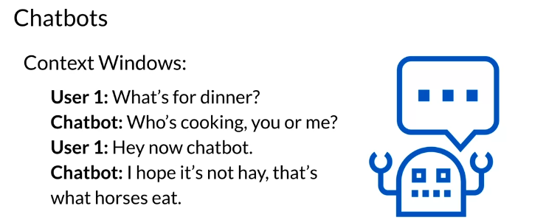

Tasks that make use of long sequences include
- Writing books
- Storytelling
- Building intelligent agents for conversations like chatbots.
This week you will learn about the bottlenecks in these larger transformer models, and solutions you can use to make them trainable for you. You will also learn about the re-former model (AKA the reversible transformer). Here is what you will be building for your programming assignment: A chatbot!

Transformer Complexity

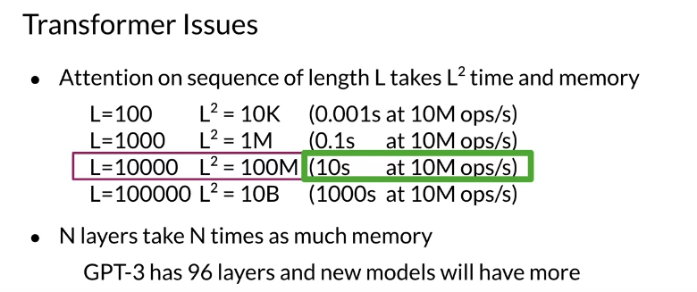

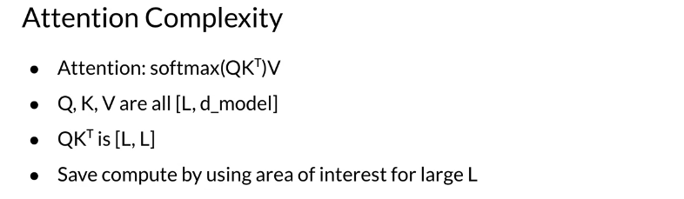

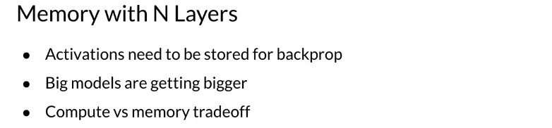

LSH Attention

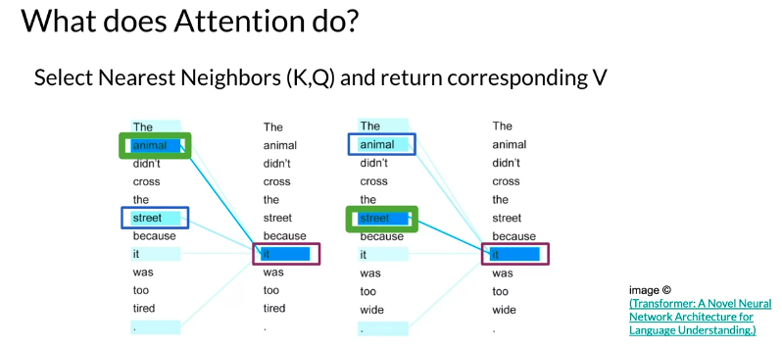

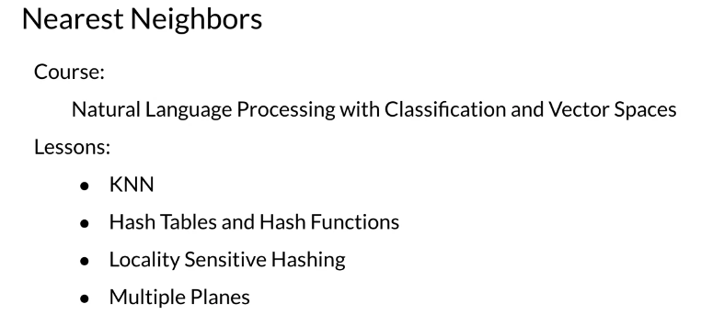

Here are the steps you follow to compute LSH given some vectors. The vectors could correspond to the transformed word embedding that your transformer outputs. Attention is used to try which query (q) and key (k) are the most similar.
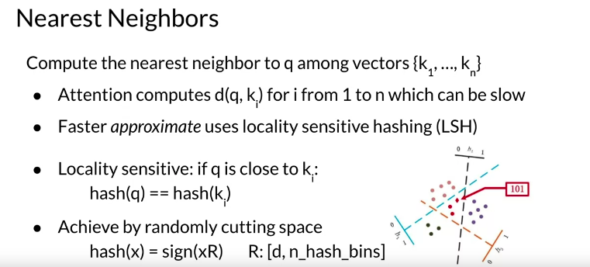
To do so, you hash q and the keys. This will put similar vectors in the same bucket that you can use. The drawing above shows the lines that separate the buckets. Those could be seen as the planes. Remember that the standard attention mechanism is defined as follows:

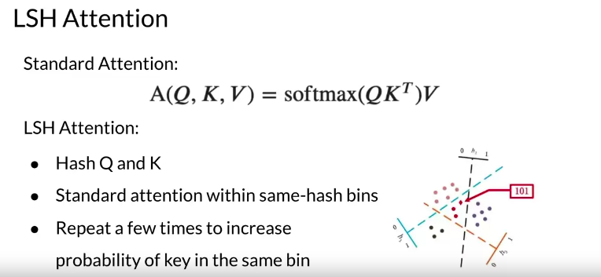

Once you hash Q and K you will then compute standard attention on the bins that you have created. You will repeat the same process several times to increase the probability of having the same key in the same bin as the query.

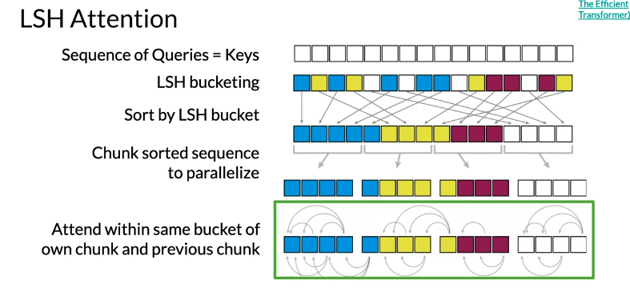
Given the sequence of queries and keys, you hash them into buckets. Check out Course 1 Week 4 for a review of the hashing. You will then sort them by bucket. You split the buckets into chunks (this is a technical detail for parallel computing purposes). You then compute the attention within the same bucket of the chunk you are looking at and the previous chunk. Why do you need to look at the previous chunk?

Motivation for Reversible Layers: Memory!

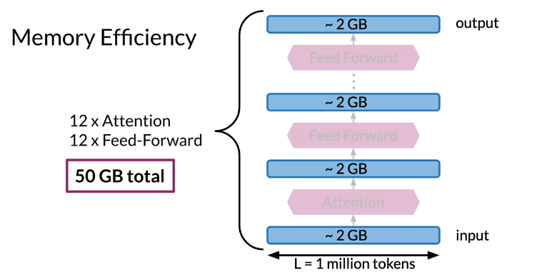

Reversible Residual Layers

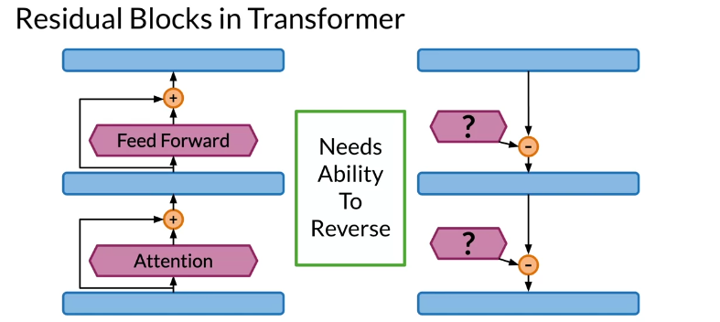

Reversible residual layers allow you to reconstruct the forward layer from the end of the network. Usually you have two similar branches in the network that you use to compute the network.
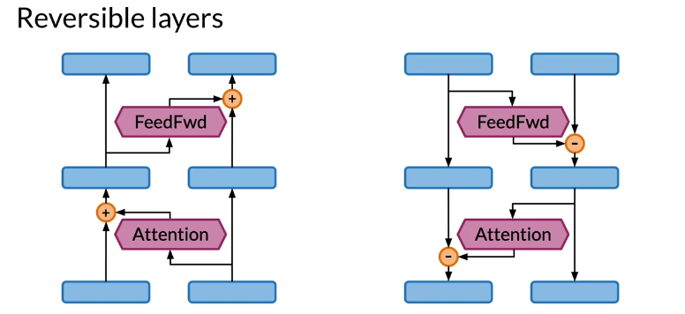

In the left picture, you have the forward propagation. One side of the network is used as input and the other is used for the attention. In the left side, the same thing is happening but in the opposite direction.

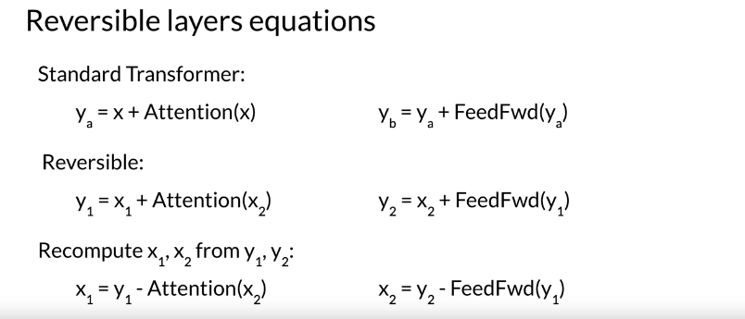
Take a few minutes and try to understand the equations above. You basically make use of the two branches of the network. When coming back for the back propagation, you only need the y's to compute x2​ and then you can use x2​ along with y1​ to compute x1​. Pretty neat! Now you don't have to store the weights, because you can just compute them from scratch. This image shows you a visualization of what is happening.

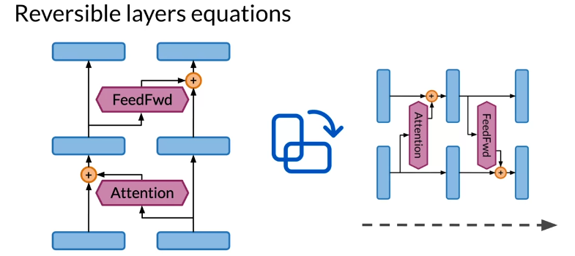

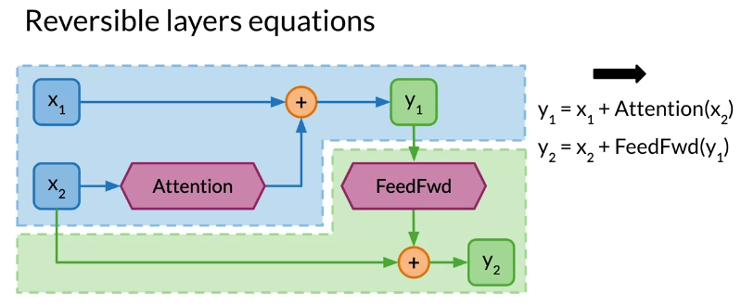

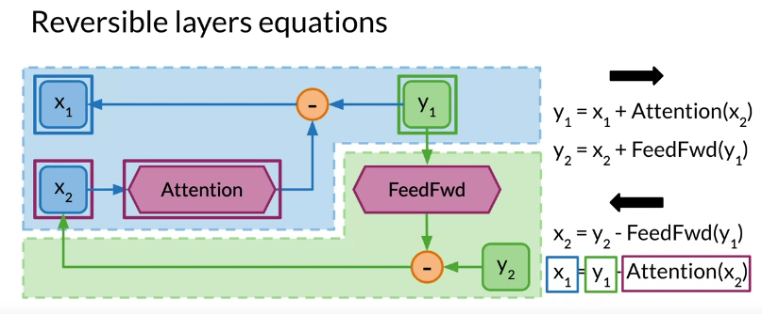
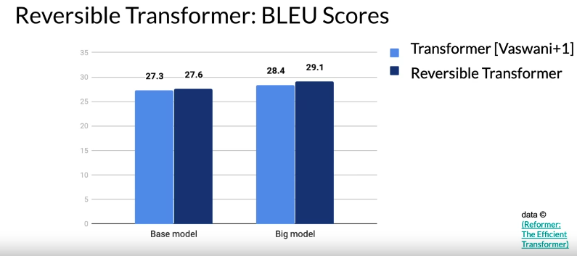

Reformer

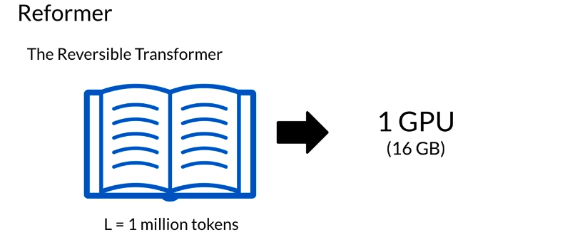
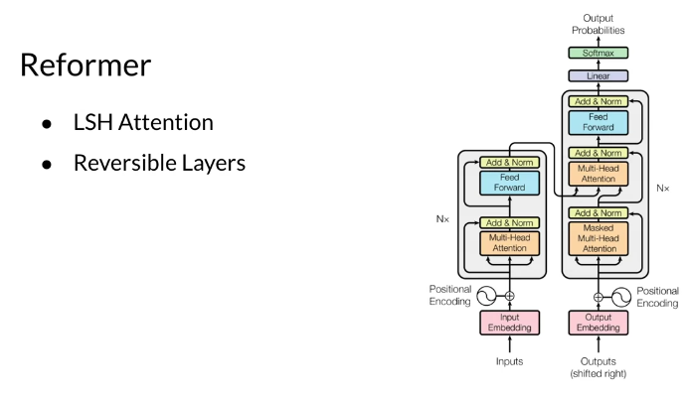
The reformer allows you to fit up to 1 million tokens on a single 16 gigabyte GPU. It is designed to handle context windows of up to 1 million words. It combines two techniques to solve the problems of attention and memory allocation which are bottlenecks for the transformer networks.
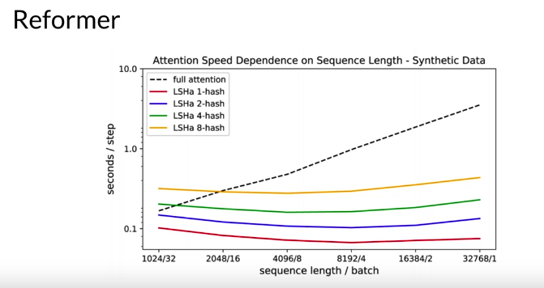
Reformer uses locality sensitive hashing, which you saw earlier in this specialization, to reduce the complexity of attending over long sequences. It also uses reversible residual layers to more efficiently use the memory available. In the picture below you can see how the reformer performs when compared to a normal full-attention model.

